Student Course Registration System
Akbar Khalil
SE-2409

1. Introduction
Course registration is a critical academic process that often faces problems such as over-enrollment, duplicate registrations, and lack of transparency for students and administrators. When these issues are not handled correctly, they lead to scheduling conflicts, administrative overload, and student dissatisfaction.
The goal of this project is to implement a core backend system that directly addresses these problems by enforcing enrollment rules, ensuring data consistency, and providing clear enrollment status. This milestone focuses on implementing and demonstrating the core functionality defined in Assignment 3.

2. Problem Being Solved
The system is designed to solve the following real-world problems:
- Courses becoming over-enrolled beyond their allowed capacity
- Students being registered multiple times for the same course
- Lack of visibility into who is enrolled or waitlisted
- No audit or traceability of enrollment actions
These problems are addressed through enforced business rules, controlled enrollment logic, and transparent system outputs.
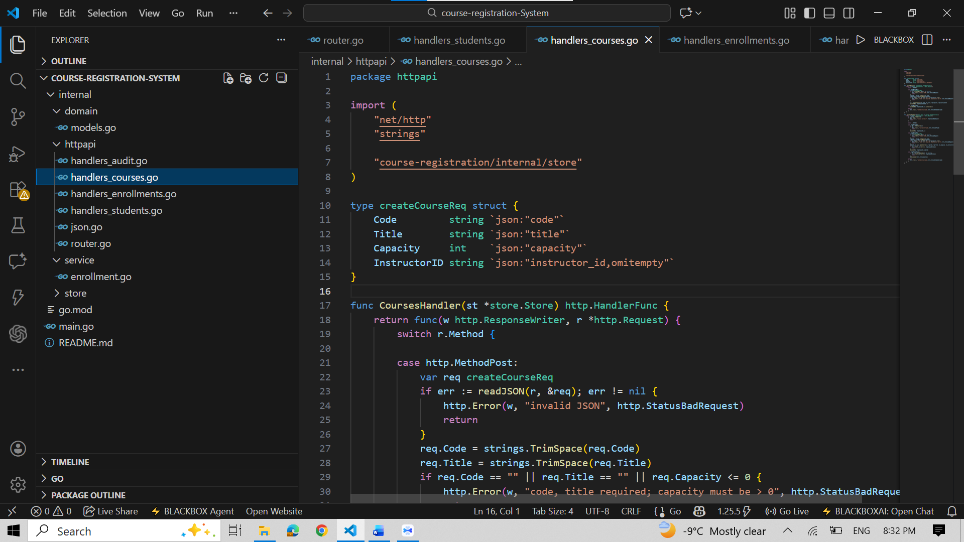
3. Implemented Core Features
The following core features were implemented to address the identified problems:
- Course Management with Capacity Control
Courses are created with a defined capacity. This capacity is enforced during enrollment to prevent over-registration.
- Student Management
Students are created as unique entities in the system to ensure reliable identification during enrollment.
- Validated Enrollment Process
The system prevents duplicate enrollments and automatically assigns a WAITLISTED status when a course reaches its capacity.
- Enrollment Visibility
Administrators and instructors can view all enrollments and their statuses (ENROLLED or WAITLISTED).
- Asynchronous Audit Logging
Enrollment actions are logged asynchronously using a background goroutine, ensuring traceability and safe concurrent processing.

4. Demonstration of the Running System
4.1 Application Startup
The backend application is started using the command:
go run .
Successful startup confirms that the system compiles correctly and the server is operational.

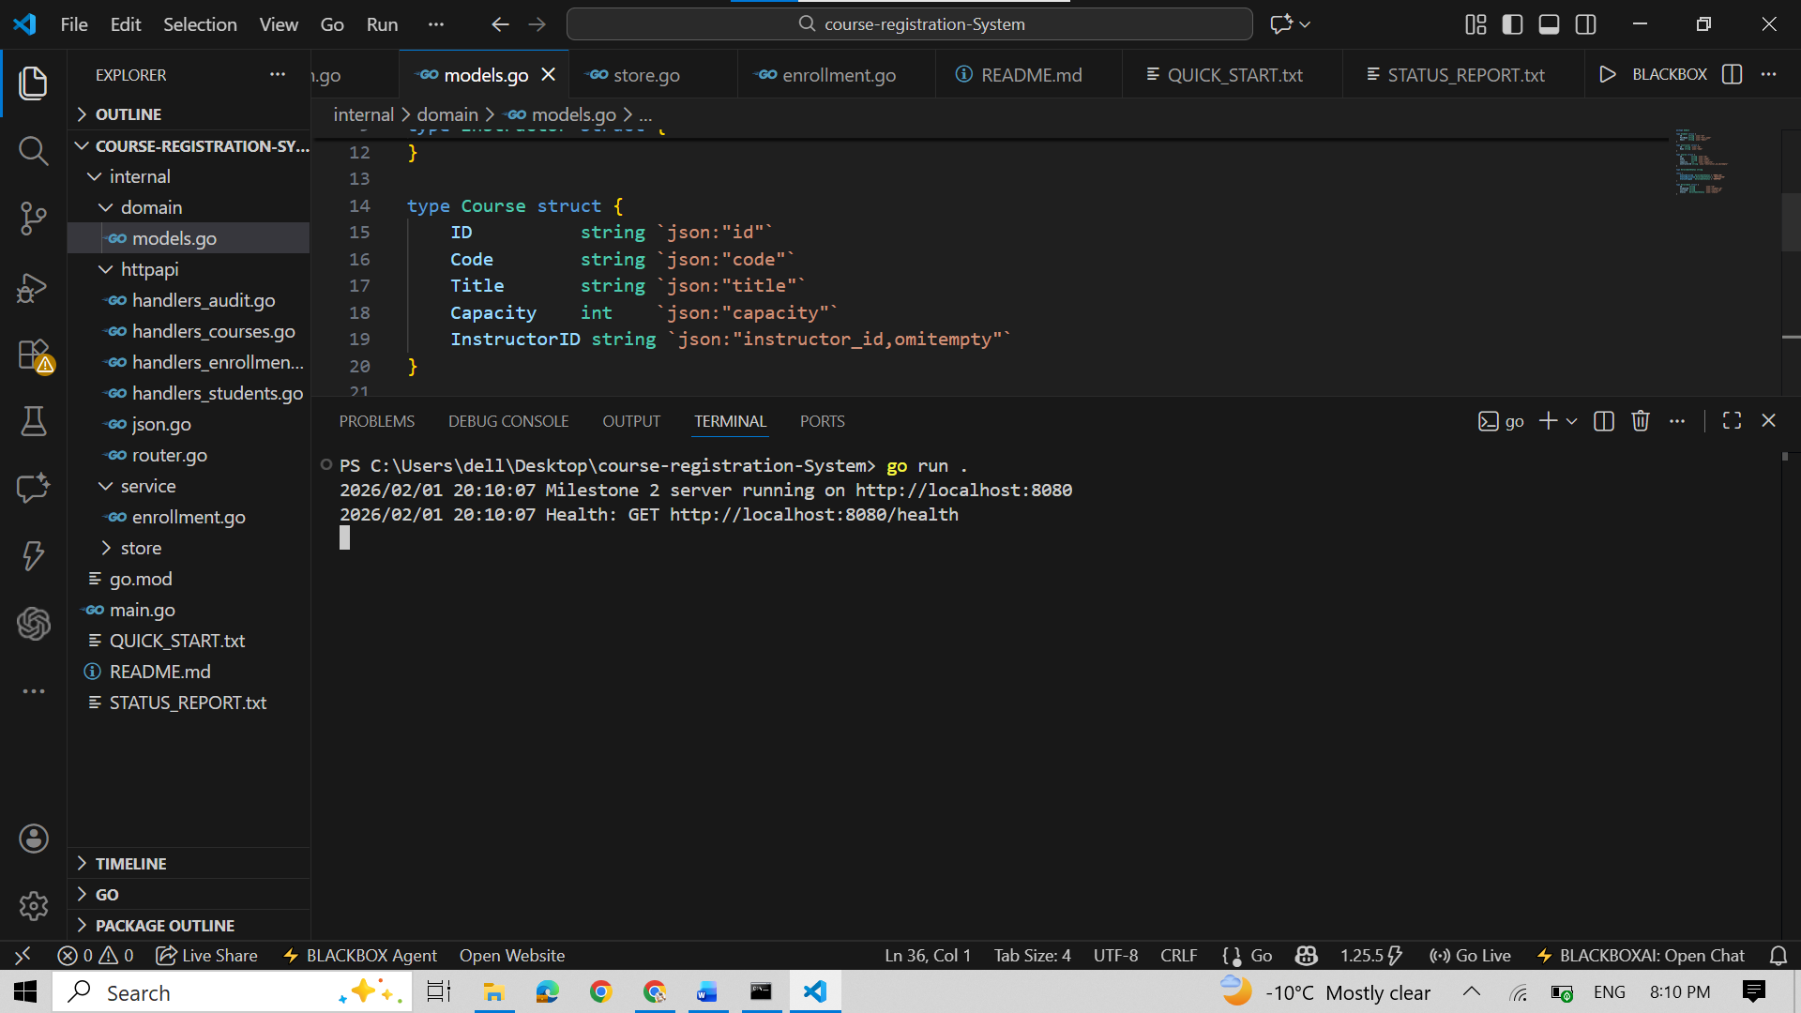

4.2 Health Check Endpoint
A health endpoint is provided at: GET /health
The endpoint returns OK, confirming that the server is running and capable of handling HTTP requests.

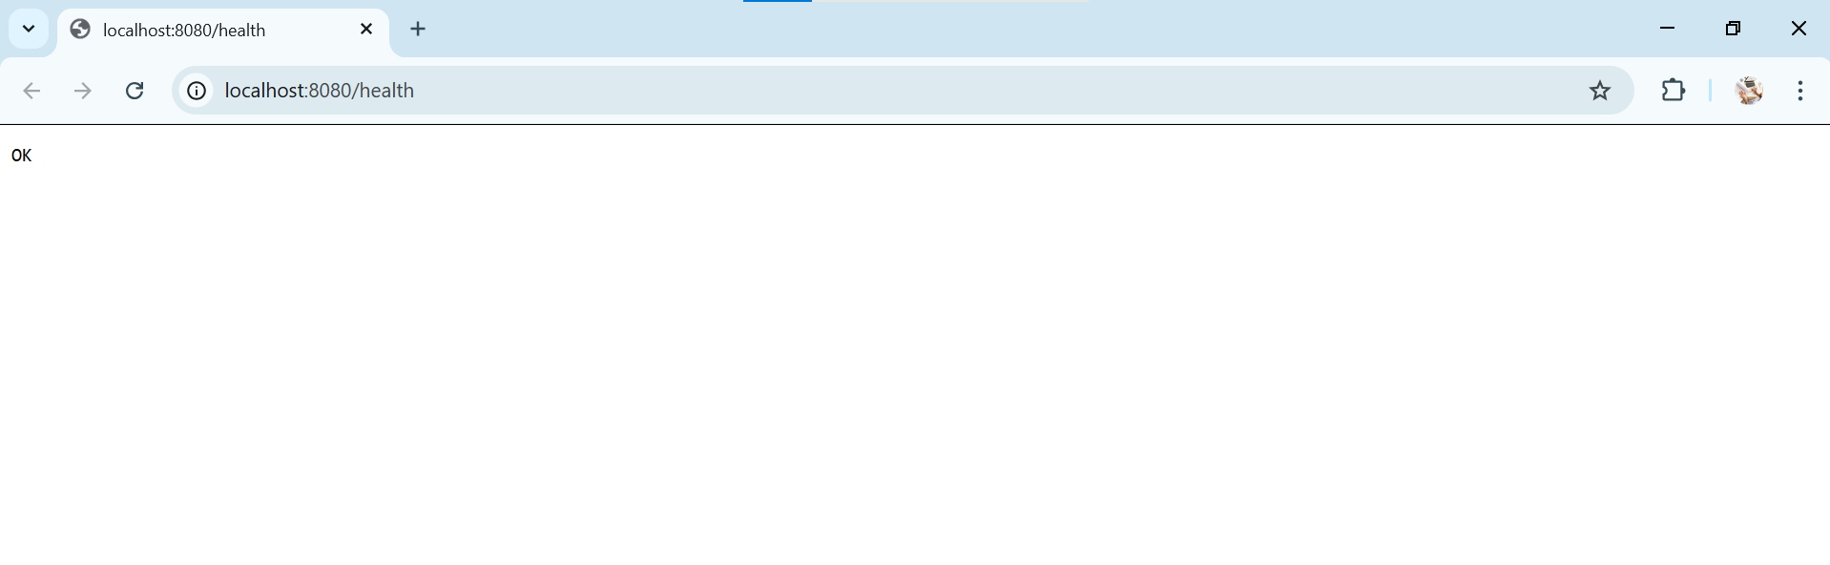

5. Feature Demonstration and Problem Solving
5.1 Course Creation with Capacity
A course is created with a defined capacity value. This capacity is later used by the enrollment logic to prevent over-enrollment.
This feature directly addresses the problem of unlimited or uncontrolled registrations.
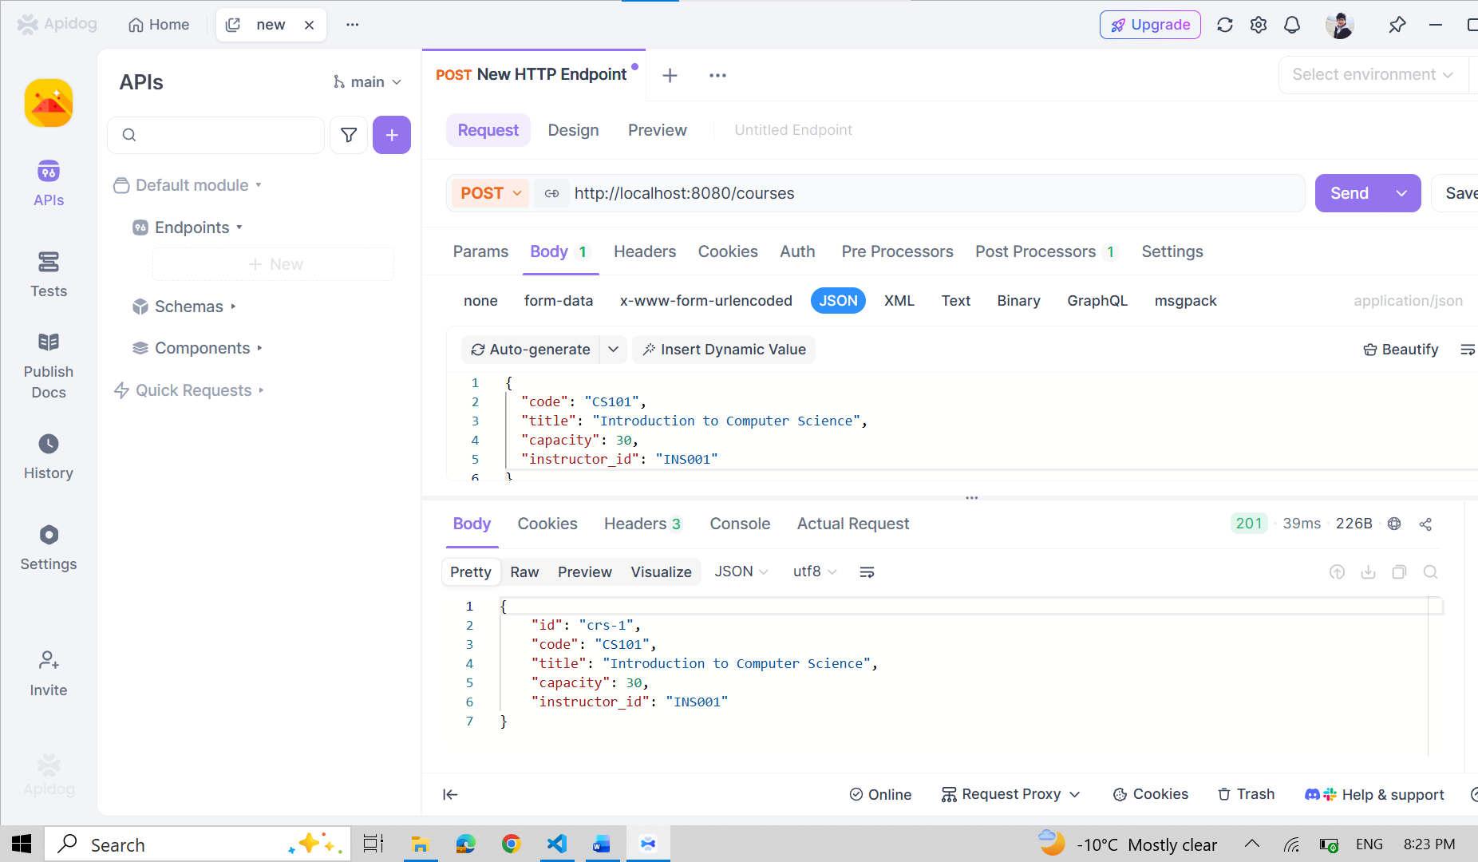

5.2 Student Creation
Students are created as individual system entities. Each student has a unique identifier, ensuring that enrollments are consistent and traceable.

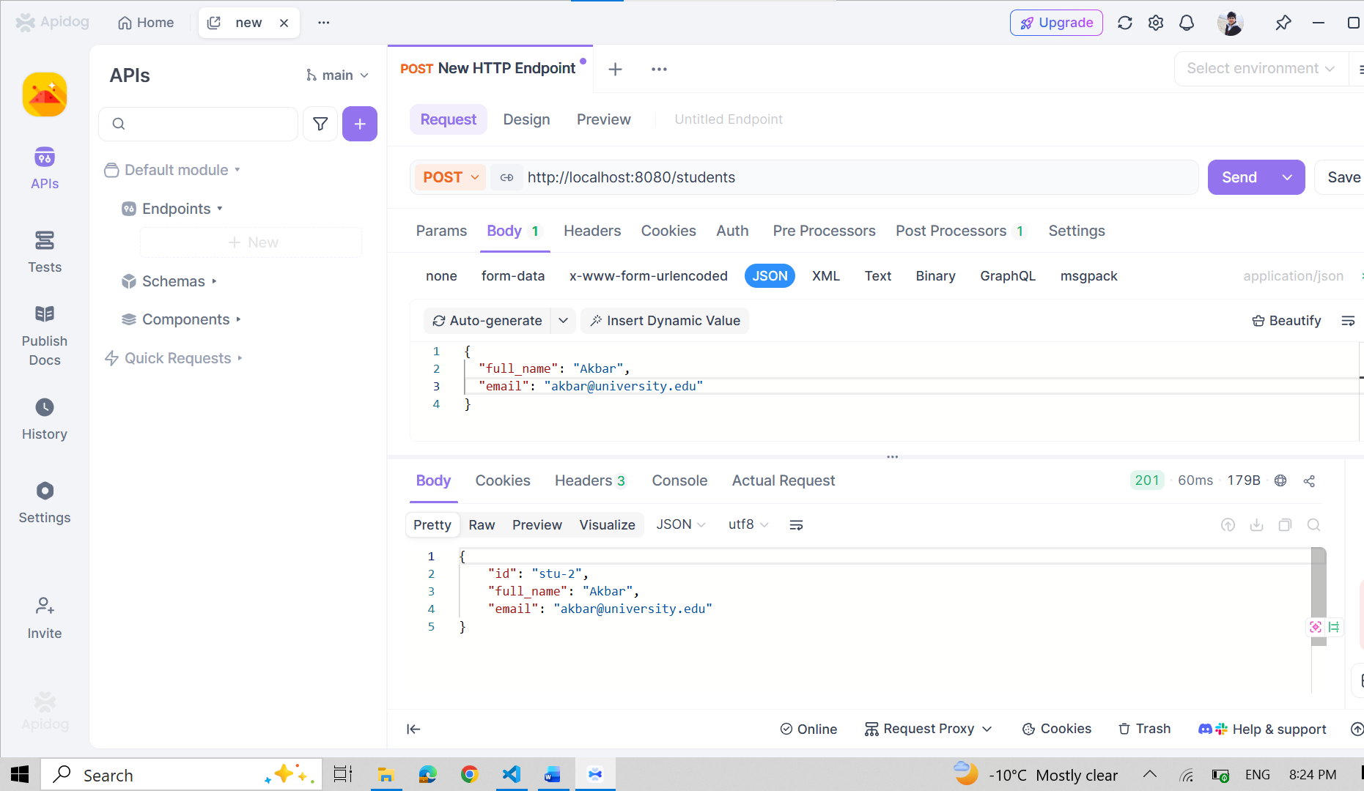

5.3 Enrollment with Capacity Enforcement
When a student attempts to enroll in a course:
- If capacity is available, the student receives an ENROLLED status
- If capacity is exceeded, the student receives a WAITLISTED status
- Duplicate enrollment attempts are rejected
This logic ensures that the system prevents over-enrollment and maintains correct enrollment rules.
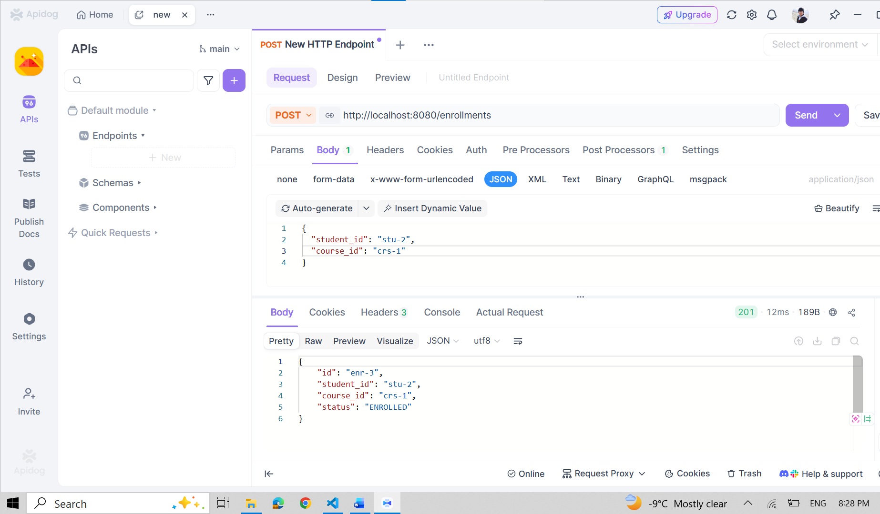

5.4 Enrollment Visibility
The system provides an endpoint to list all enrollments. Each enrollment includes the student ID, course ID, and enrollment status.
This feature improves transparency and allows administrators to clearly see the current registration state.
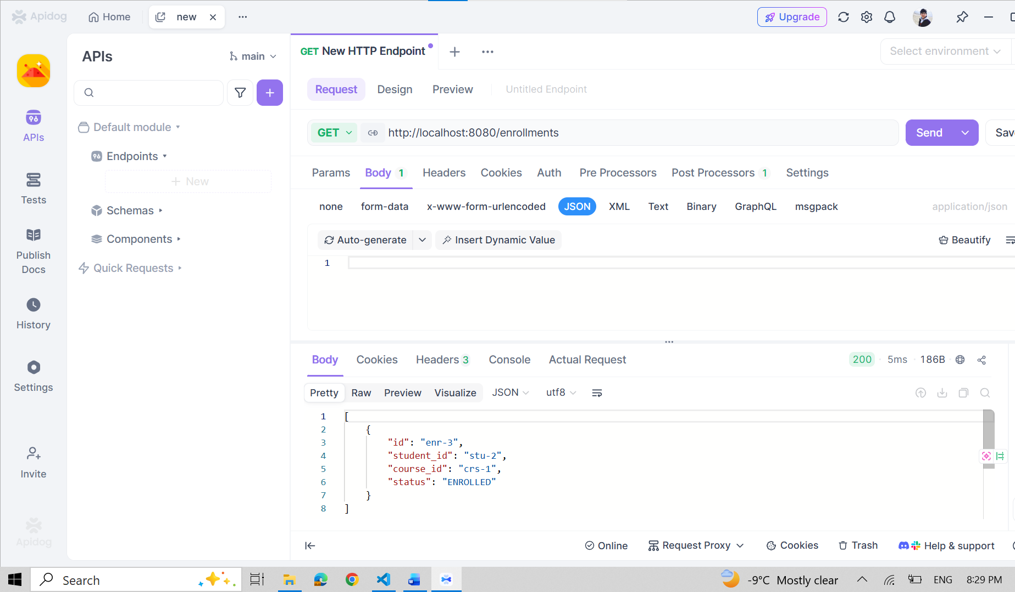
6. Concurrency and Asynchronous Processing
To satisfy concurrency requirements, the system includes a background goroutine that processes audit events asynchronously using a channel.
Every enrollment action generates an audit event that is handled by the audit worker without blocking the main request flow. This demonstrates safe concurrent execution and improves system responsiveness.

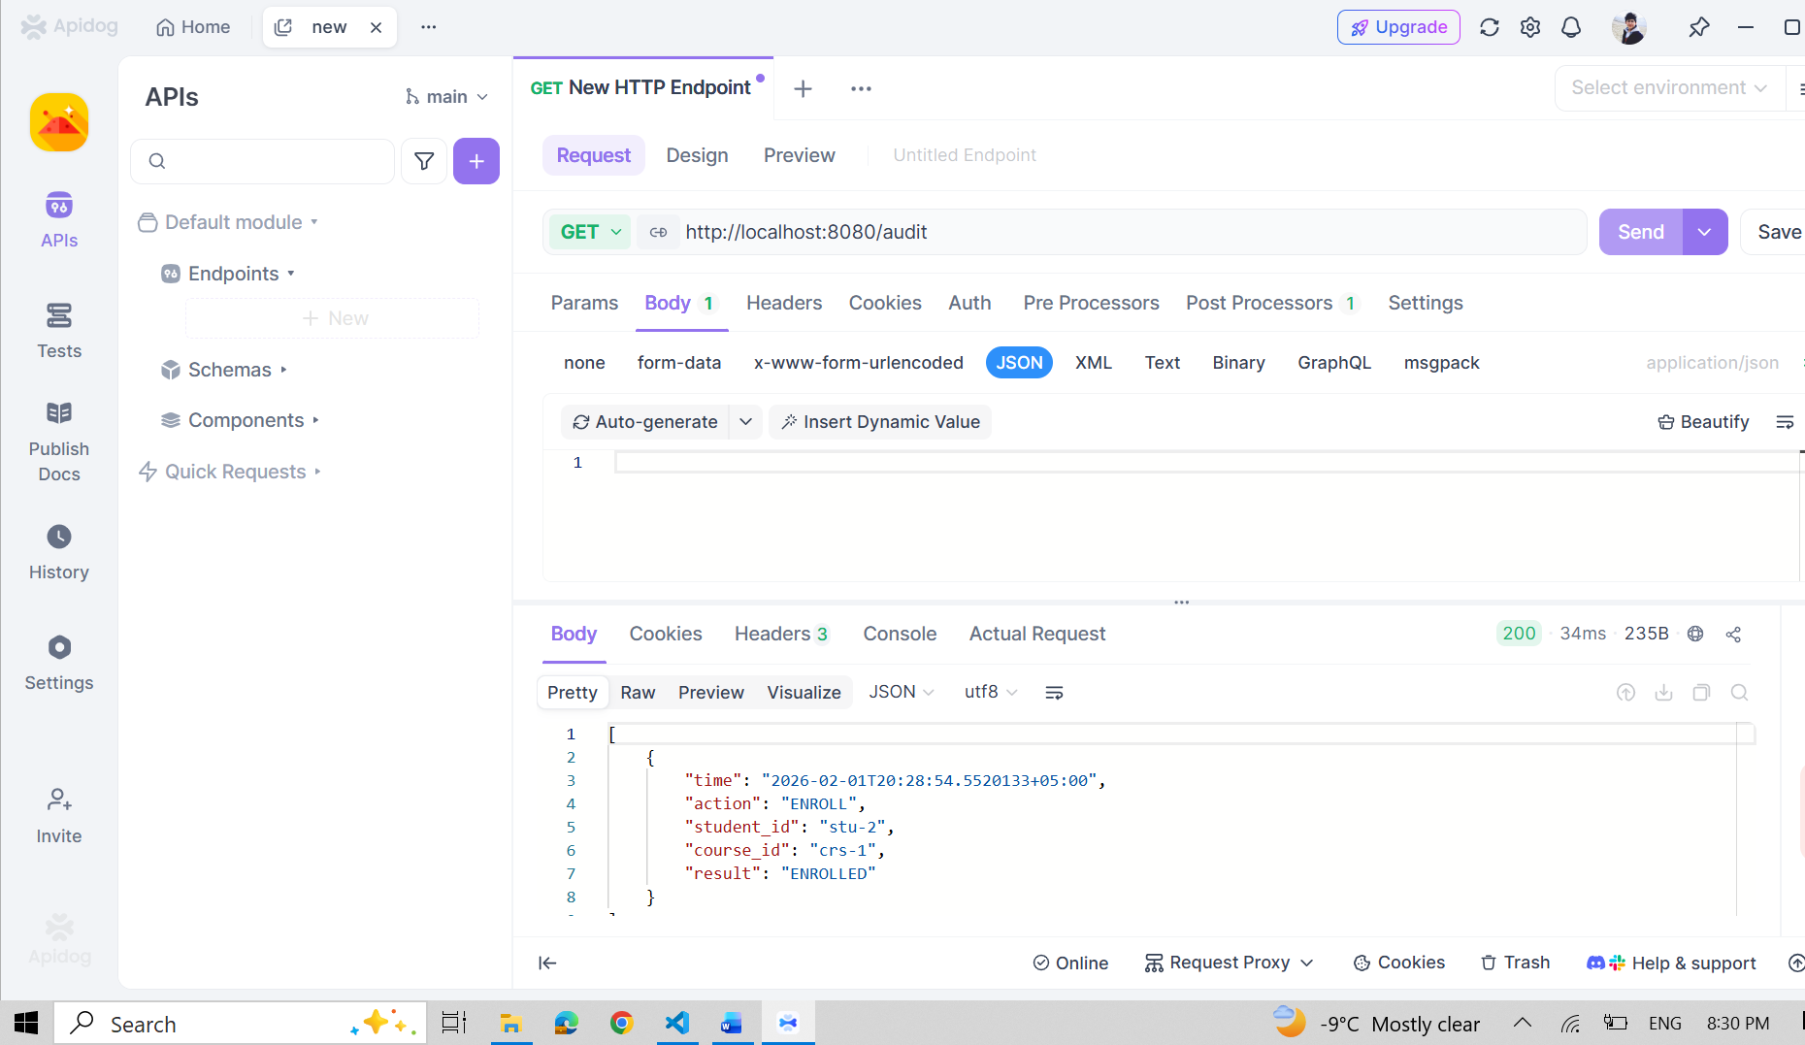

7. Consistency with Assignment 3 Design
The implementation directly follows the design defined in Assignment 3:
- Core entities (Student, Course, Enrollment) match the ERD
- Implemented endpoints correspond to defined use cases
- The system uses a monolithic architecture with modular separation
- Business rules are implemented at the service layer
This ensures continuity between system design and implementation.

8. GitHub link: https://github.com/1013akbar/Adv-final.git

9. Conclusion
This milestone demonstrates a functional backend system that solves real registration problems through enforced rules, controlled enrollment, and clear visibility. The application successfully runs, processes concurrent operations safely, and follows the architectural design defined in the previous assignment.
The system is now prepared for further extension and refinement in future milestones.

